Lab3

**Name-Maniya Motiramani**

**Class-D15b/38**

install minikube and run following command minikube version

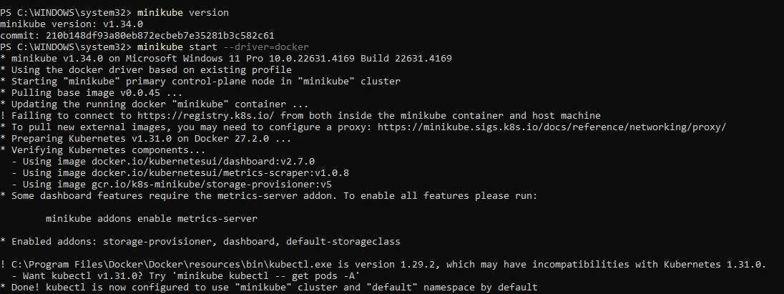Start minikube cluster :minikube start --driver=docker

Verify Minikube status minikube status install kubectl

curl -LO "https://storage.googleapis.com/kubernetes-release/release/$(curl -s https://storage.googleapis.com/kubernetesrelease/release/stable.txt)/bin/windo ws/amd64/kubectl.exe" Verify installation kubectl version --client

Deploy an Application on Kubernetes create a Deployment kubectl create deployment nginx --image=nginx Expose the Deployment kubectl expose deployment nginx -- type=NodePort --port=80

1

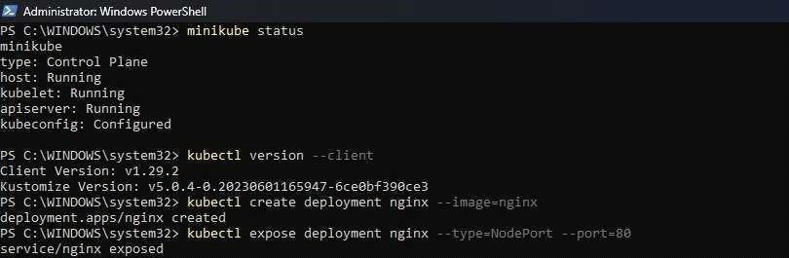

Get the URL minikube service nginx --url

Manage Kubernetes Cluster

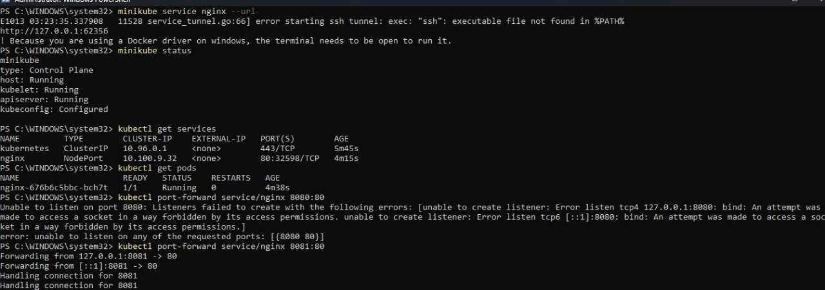To see running pods: kubectl get pods To check services:kubectl get services

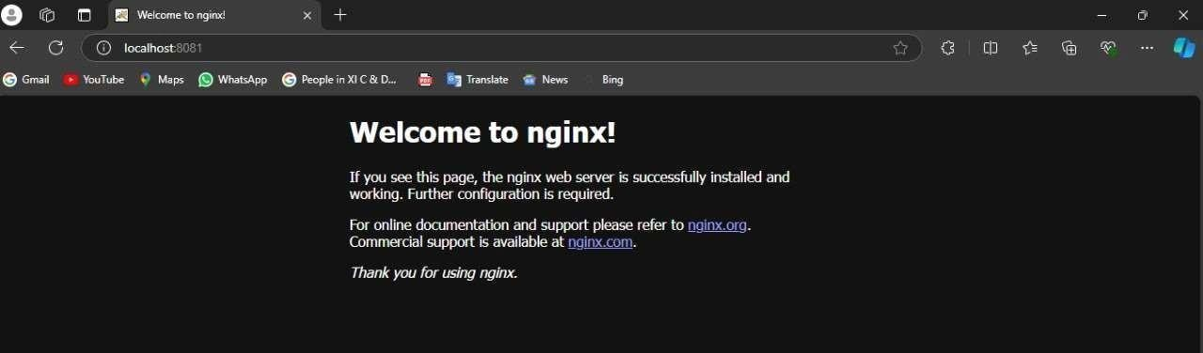Navigate to localhost

2